Useful quotes

* Moreau, A century of Ratings

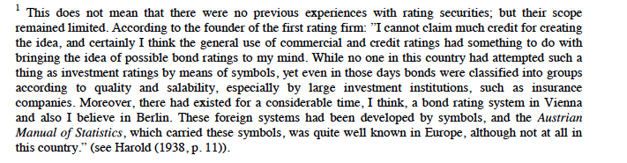

* Moodys First 100 Years

Worked at Spencer Trask. Rose through the ranks and became head of research. (Probably helped him with contacts within industry, and understanding of firms).

Page 25. On Moody’s decision to start producing the statistical volume in 1899.

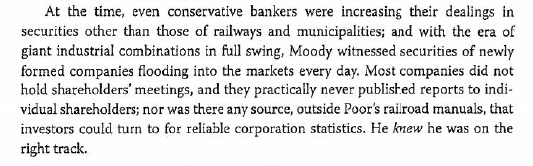

Pg 39 The Moody went bankrupt in 1907, the Moody Publishing Company was purchased by Roger Babson, who published the Moody’s Manuals for the next 16 years.

Pg 43 On the origins of securities ratings

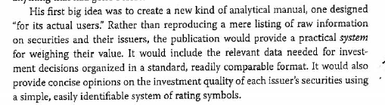

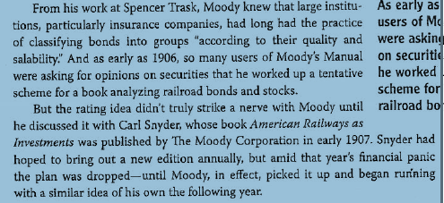

Some bond ratings had existed in Vienna and possibly Berlin for some time. Austrian Manual of Statistics used symbols. Not clear he knew this until much later.

Securities markets were in the upswing in 1908, so it was the right time for ratings.

Method he used was at least in part borrowed from the Bradstreets and the Duns. Bradsteet used up to 13 digits to summarize creditworthiness of businesses or individuals since 1850s, although used cumbersome system. In 1857, developed single rating system that conveyed his overall opinion using capital letters A-E, and then adding a double A to identify the strongest credits (Aa, A, B, …, E). Dun did the same in 1859 using number (1, 1 ½,… 4).

Moodys said that Aaa to A were good, with little difference among them. Baa had a “speculative tinge.”

Suring 1930s, division between investment grade (Baa and above) and speculative-grade (Ba and lower) came to be a market and regulatory benchmark.

E and F were added in 1914, and dropped in 1923. In 1930, dropped Daa, Da and D.

Initial ratings were not specifically credit ratings; they were used to rate the overall “investment quality” of all of each company’s outstanding securities.

Stocks ratings were mostly a reflection of salability; they were discontinued in 1935.

Salability and other elements of investment quality stopped playing a role when ratings focused on providing a reliable measure of credit quality, in the 1970s.

Comments at the time of publishing in 1909 focused on detailed analysis of securities, and not on ratings.

**Page 51: ratings narrowed the bid-ask spread, and facilitated the valuation of bonds by investors:**

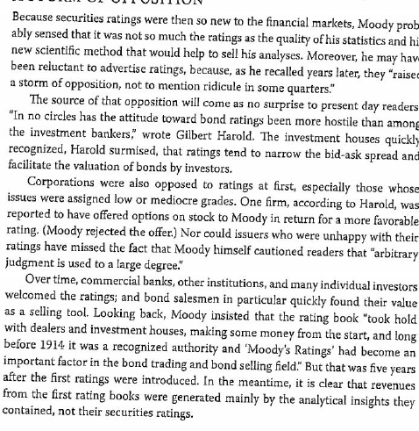

Pg 54: ratings book was profitable within the first year (but weekly investment advisory letter service seems to have generated large share of his profits).

Price difference with competitor Moody Manual. After 1914, he sold each Rrd and Industrial/Publ Util for $15 each, and for $25 combined. Moody’s Manuals were sold at $20 each, with no discounts for purchasing both.

Suffered a bit when markets closed down during war, but sales soared in 1916 as markets expanded.

Pg 66: In 1912, ratings on RRd securities covered more thank half of the dollar volume of US corporate bonds outstanding, With intro of public utility ratings, Moody’s rated more than 90% of the market by 1920.

In “The Story of an Institution” he said that he had more than 500 banking firms, and 250 banks in NYC, plus several thousand banks and financial institutions outside NY, and several thousand individual investors scattered around America as regular subscribers for his services in 1916.

Page 61:

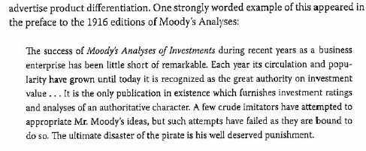

In 1917 started rating book on foreign and American government and municipal securities. In 1918, split the Pub Utilities and Industrials manuals into two.

Page 91: Active market for “junk bonds” in the 1920s. Market grew as Moody’s began rating public utilities and industrials in 1914, and then other agencies also entered the bond rating market. Few new low-grade bonds were issues with onset of Depression in 1921, but wholesale downgrading of outstanding bonds, and then slow to upgrade as conditions improved. Thus, high-yield bonds (mainly “fallen angels”) made up a large portion of the corporate market through 1940s and beyond.

Competition: Poor’s started publishing ratings on stock and bonds in 1916, with a similar scale. Standard Statistics started rating stock and bonds in 1922, also similar scale. Fitch began rating corporate debt in 1922, first published publicly in 1923 using AAA-D scale.

Even though some companies rated below D, it was understood that D meant “practically valueless” and that any categories below “were not ratings in the strict sense of the word.” (See page 67)

By 1923, had a large group of experts working on the ratings. Competition diminished. In 1924, sold 24,000 copies of the manuals ($20 each).

Bought back right to use Moody in name of manuals from poor’s in 1924.

Moody’s Investor Service went public on Nov 14, 1928, until bought by Dun & Bradstreet in early 1960s.

Page 79: Interesting comment on going public, and push of bankers searching for underwritings during the boom market of the late 1920s:

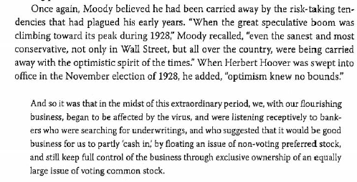

Completely missed predicting the 1929 Crash. Competitor Roger Babson was among the first to predict crash and ensuing Depression.

Revenues got severely hit in 1931, but then rebounded somewhat because demand for ratings and other services increased as securities prices continued to fall and bond defaults spread fear of further losses. Did not reach 1929 levels, though, for 25 years or so.

Weekly updates on new securities and rating changes since 1931.

Moody’s did not begin charging issuer rating fees until 1970. But ratings still made manuals attractive to investors during wave of bond defaults in 1930s. Tons of downgrades; rating companies were slow to upgrade ratings during the following decade for fear of a repeat of the capital mkt crisis.

Harold (book 1938) argued that 1930s led to increased reliance in ratings by commercial bankers. Commercial banks had always been largest single group of raying adherents.